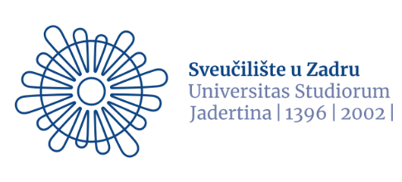
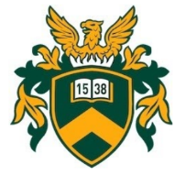
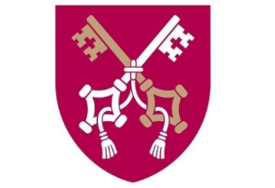

Pontifical University of John Paul in Krakow Sveučilište u Zadru University of Debrecen
Institute Family, Pedagogy and Social Work Faculty of Education for Children and Special Education

EDUCATION IN THE FAMILY – THE FAMILY IN EDUCATION

IV. International Conference on the Family and Education
22th May 2024
Zadar, Croatia

We are pleased to invite you to attend this conference devoted to the family and education. Despite numerous crises which have been affecting the family, it still remains the basic educational environment. As a social group, it is also part of the national educational system which has been undergoing dynamic changes. This dependence shows considerable educational potential which may offer children, teenagers, adults and older family members opportunities for development. We are aware of deficiencies and obstacles in the process of education in the family. We notice great needs in the social dimension of education. Therefore, it is crucially important to organise academic meetings and have discussions on this issue.
Main topics:
- Education in the family
- The family in the educational system
- Social aspects of education
- Education for ethnic minorities
- Issues of Special Educational Needs

In addition, a session will be devoted to presentations given by MA students

We invite researchers, academic teachers, PhD students and people working with families to register for the conference. If you would like to attend the conference as a listener and receive a certificate, please fill out the registration form available below.
Deadline for registration:
April 30th, 2024
The conference will organized on-site. The conference will be held at
1 Mihovila Pavlinovića Street,University of Zadar, Croatia

Official language of the conference: English

Information on acceptance of the abstracts will be sent within five working days.

All the accepted abstracts will be published in an abstract book with an ISBN number.

Registration fee:
for speakers 50 EUR
PhD students 20 EUR

Publishing conference papers
Conference papers can be published in Különleges Bánásmód [Special Treatment] which is an online, interdisciplinary Open Access journal run by the University of Debrecen, Hungary. Every paper published in Különleges Bánásmód has its DOI number (Digital Object Identifier). Különleges Bánásmód [Special Treatment] is in the process of being involved in Scopus Content Selection (more info: https://ojs.lib.unideb.hu/kulonlegesbanasmod). Participants will be informed about the publication of papers at a later date.

Conference Committee

Committee chairs:

- Arkadiusz Krasicki, PhD, Associate Professor at Sveučilište u Zadru
- Gortka-Rákó Erzsébet, Associate Professor at University of Debrecen
- Godawa Grzegorz, Associate Professor at The Pontifical University of John Paul II in Krakow

Scientific committee:

- Marijana Mohorić PhD, Assistant Professor at the University of Zadar
- Elvis Ražov PhD, Associate Professor at the University of Zadar
- Monika Pyrczak-Piega, PhD Pontifical University of John Paul II in Cracow
- Gortka-Rákó Erzsébet, PhD Associate Professor at the University of Debrecen
- Túri-Galán Anita, PhD Associate Professor at University of Debrecen

Organising committee:

- Nemes Magdolna, PhD Senior Lecturer at University of Debrecen
- Ochońska Magdalena, PhD, Pontifical University of John Paul II in Cracow
- Zdenko Dundović PhD, Associate Professor at the University of Zadar
- Damir Šehić PhD, Assistant Professor at the University of Zadar
- Ante Sorić PhD, University of Zadar
- Ariana Mračić, mag. paed. et mag. soc.
- Bojan Rizvan, mag. theol

Registration for speakers:
www.pedagogy-conference.eu

Contact: akrasicki@unizd.hr or nemesm@ped.unideb.hu

We look forward to seeing you at Education in the family – The family in education conference on 22 May 2024 in Zadar.
Sincerely,

Arkadiusz Krasicki
Associate Professor at University of Zadar

Gortka-Rákó Erzsébet
Associate Professor
University of Debrecen

Godawa Grzegorz
Associate Professor
Pontifical University of John Paul II in Krakow

